**PROJECT DEVELOPMENT PHASE**

**Sprint 3**

|  |  |
| --- | --- |
| Date | 18 November 2022 |
| Team ID | PNT2022TMID35481 |
| Project Name | AI Based Discourse for Banking Industry |

**NET BANKING ACTION**

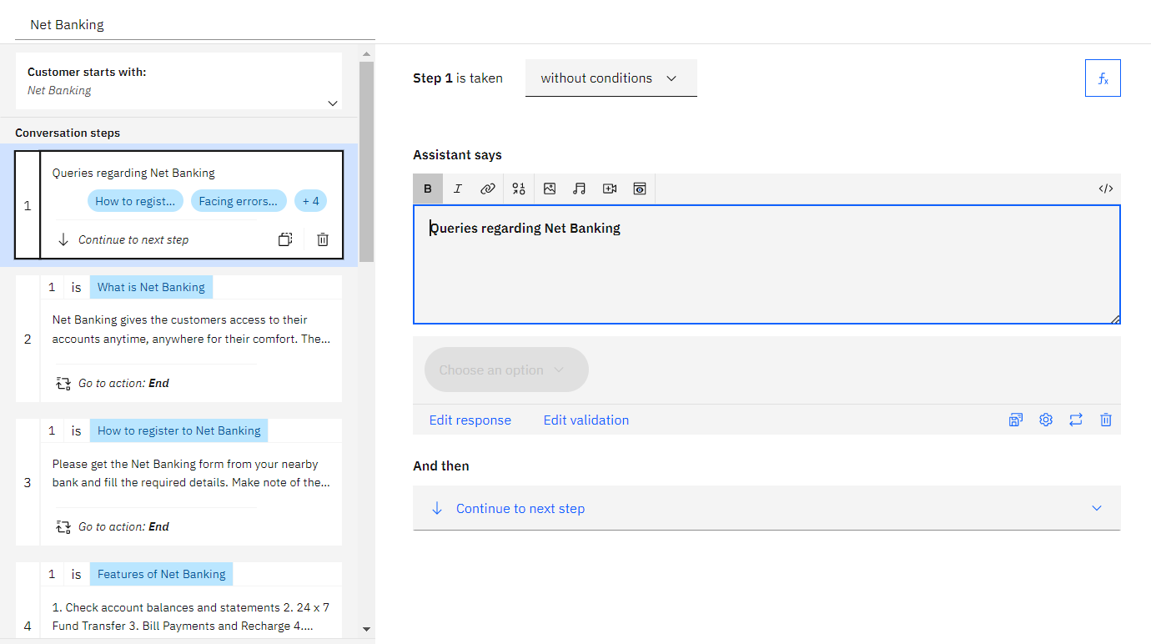

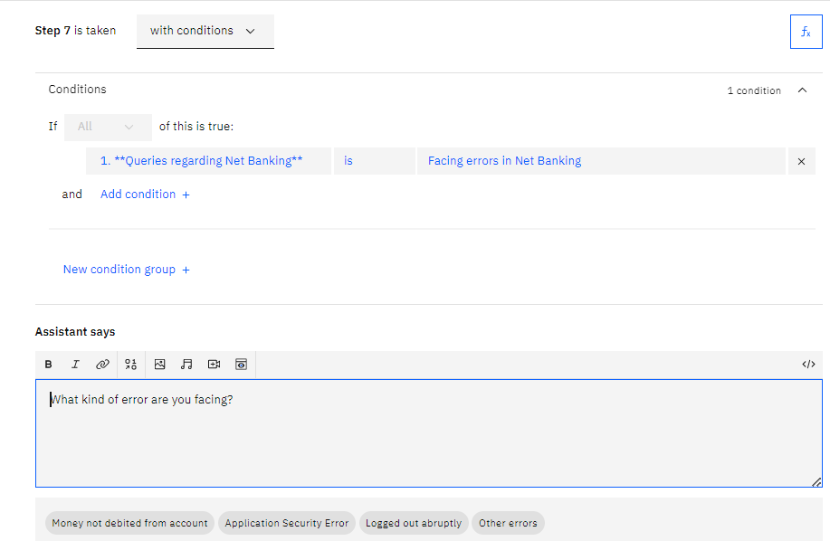

Preview:

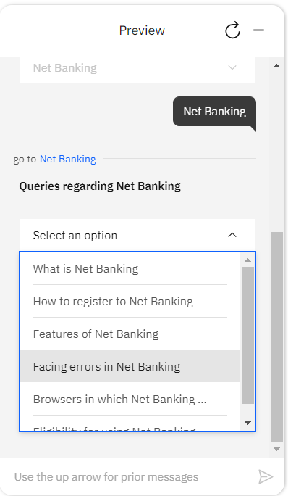 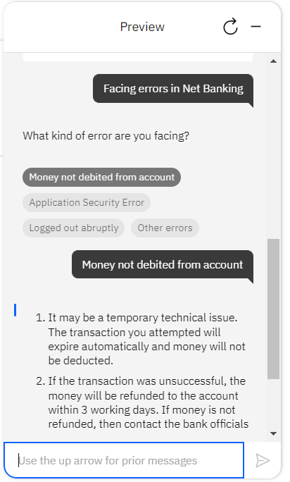

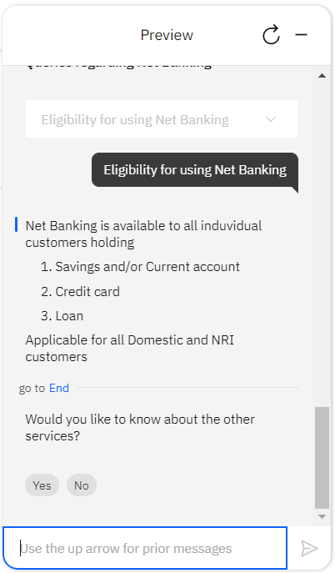

PYTHON CODE FOR RUNNING THE APPLICATION WHICH CAN BE DONE ONCE THE WEB PAGE GETS READY:

